Exercise 9

1. Please modify Fig 13.3 to create a canvas application.
   * It allows the user to draw inside a table element in red, blue or **black** by holding down the Shift key, Ctrl key, or **Alt key** and moving the mouse over the box.

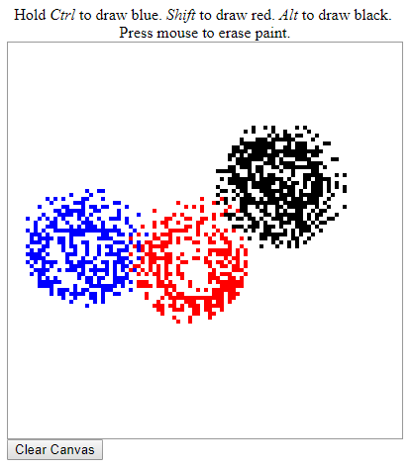

* + When pressing the mouse, you can erase the color of the table element. (按住滑鼠移動可以擦去著色) (Hint: <https://www.w3schools.com/jsref/obj_mouseevent.asp> )
  + The drawing will be kept permanently even when closing and re-opening the browser. (重開瀏覽器畫過的圖仍會出現) (Hint: localStorage)
  + When pressing the [Clear Canvas] button, all the drawing will be removed. (連同localStorage中的資料也要清除)

1. Please develop a Tic-tac-toe game (井字遊戲).
   * The initial UI is shown as follows: (Please refer to ex-9-2-basic.html)

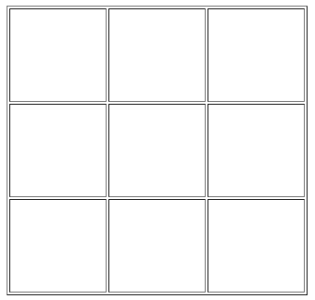

* + The first player can click any blank grid to let an "X" symbol to be displayed in the selected grid.

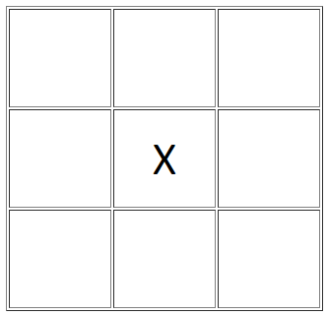

* + The second player can click other blank grids to let an "O" symbol to be displayed in the selected grid.

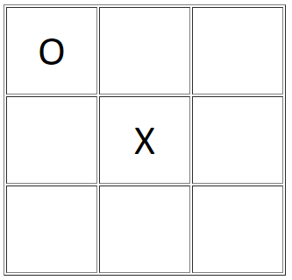

* + You can deduce the rest from the previous two rules.

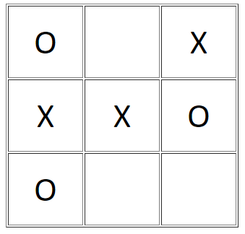

* Please show a message using window.alert(): "Not allowed" when a grid with O/X symbol is clicked .
* Please determine who wins the game or tie: the player who succeeds in placing three of their marks in a horizontal, vertical, or diagonal row wins the game, and show a message using window.alert(): “X wins!”, “O wins!”, or “Tie!”.
* Please reset all status when the “New Game” button is clicked.

Bonus:

* Please replay (重播) all steps during the game when the “Replay” button is clicked.

Hint:

* 可以給予button有規則的id，以便能進行後續處理。
* 建議設計合適的資料結構紀錄目前所有的O或X，以協助判斷輸贏。
* 顯示比賽結果訊息時，有可能需要透過window.setTimeout()讓其暫緩顯示，避免結果訊息比最後一步還快顯示。
* 要能做到重播，必須要能記錄每一步的走法，再透過window.setInterval()模擬全部歷程。